Whois Tier-Layer Package Diagram

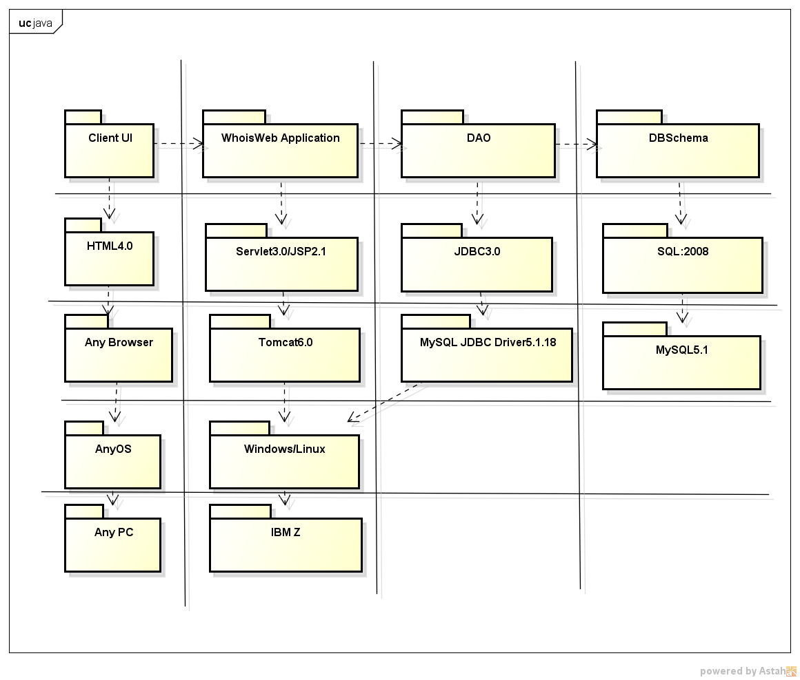

The figure depicts a system of layers of selected technical。The system is divided into five Tier (client layer, presentation layer, business layer, integration layer and resource layer) and five Layer (hardware layer, the underlying platform, the upper platform layer, the virtual platform layer and application layer)